Suspicious Activity Detection using CNN

In this project we have utilized CNN algorithm to detect various suspicious activities such as Fight, Fire, Theft, shooting etc. in below screen showing various classes used to train model

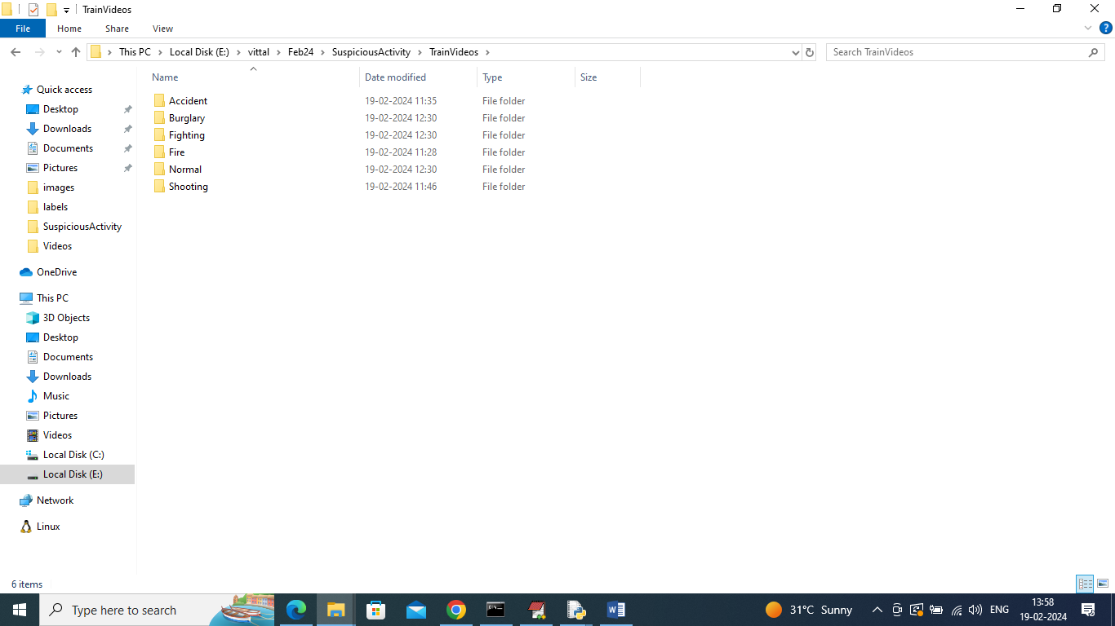

In above Train Video folder we have all possible suspicious activities class labels videos and by using above videos will train model. Model will get trained on 80% dataset features and get tested on 20% test features to calculate prediction accuracy.

SCREEN SHOTS

To run project double click on run.bat file to start web server

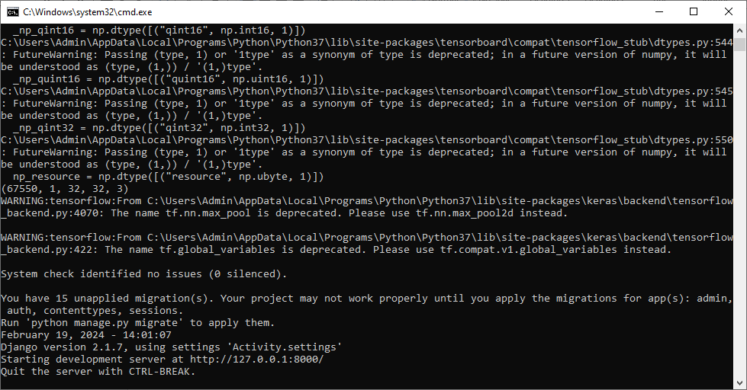

In above screen python web server started and now open browser and enter URL as <http://127.0.0.1:8000/index.html> and press enter key to get below page

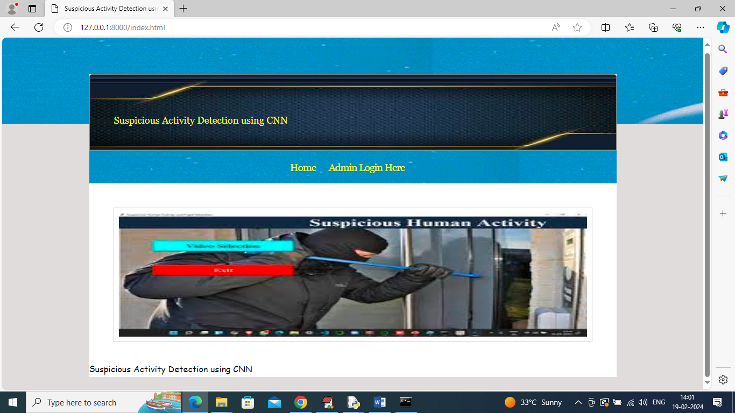

In above screen click on ‘Admin Login’ link to get below login page

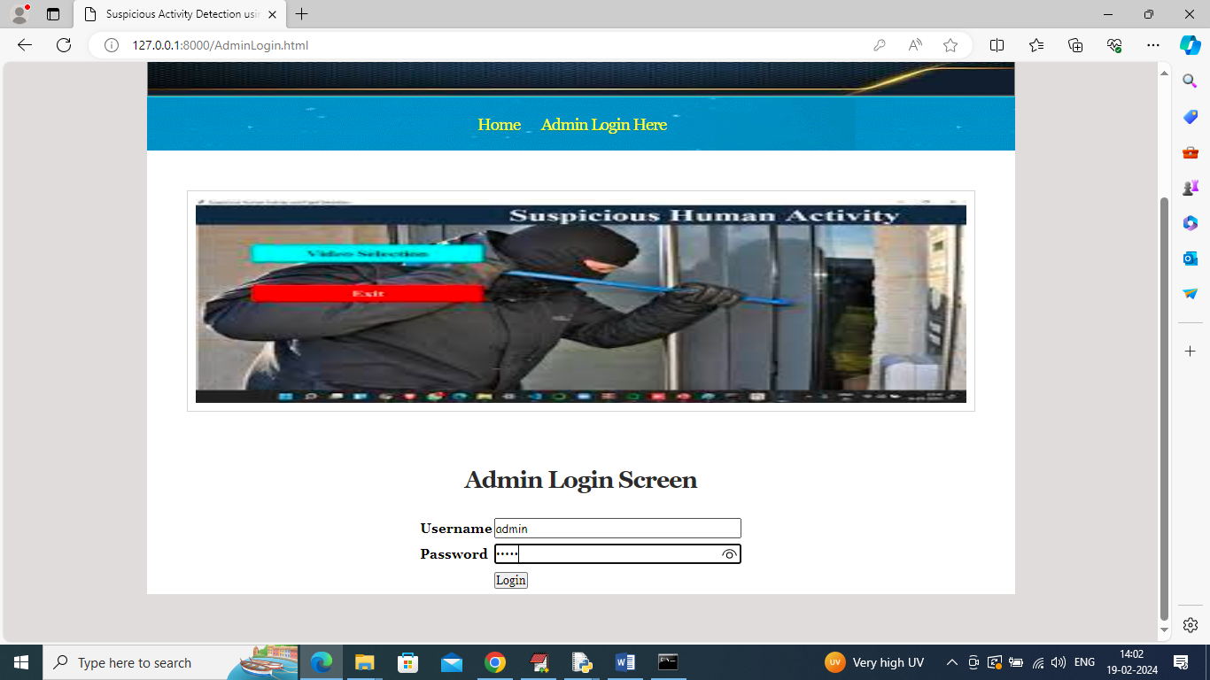

In above screen admin can login to system using username and password as ‘admin’ and after login will get below page

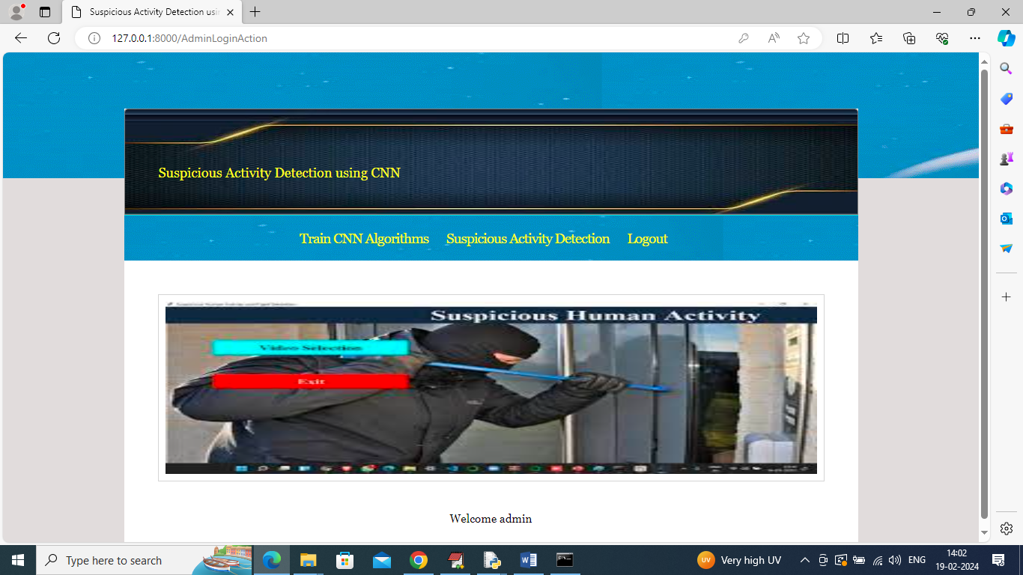

In above screen click on ‘Train CNN Algorithm’ to train model and get below page

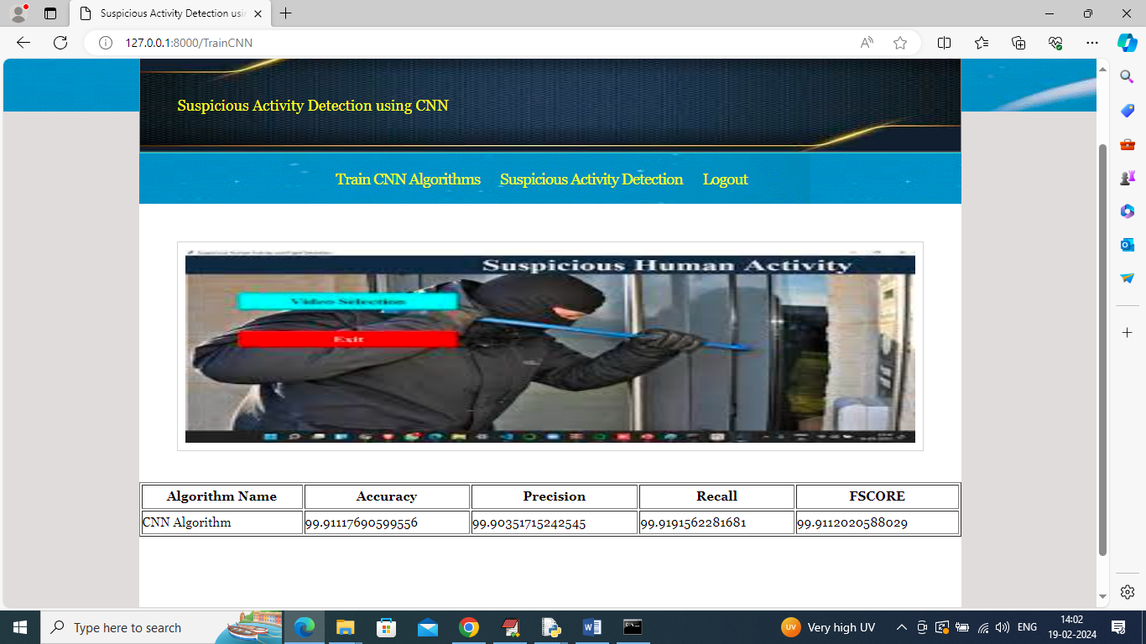

In above screen CNN training completed and it got 99% accuracy on test and now click on ‘Suspicious Activity Detection’ link to get below page

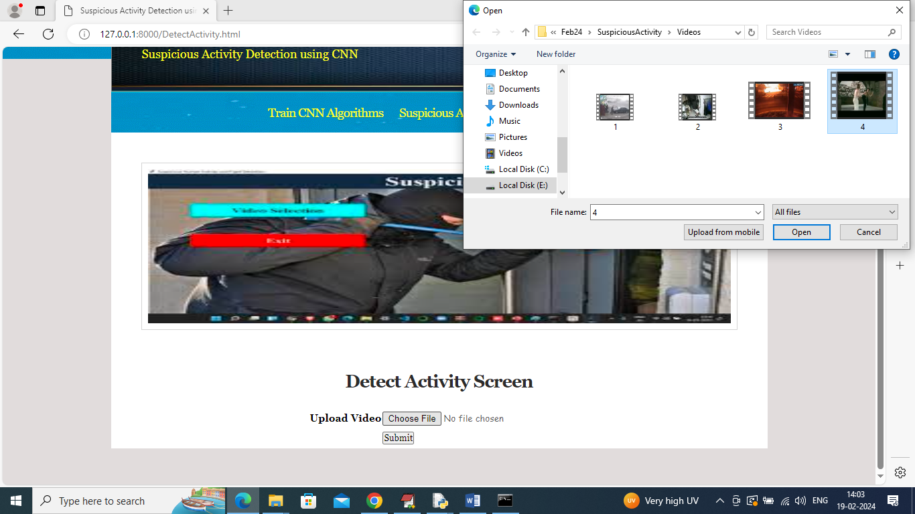

In above screen upload any video and then click on ‘Open’ and ‘Submit’ button to play video with detection



In above screen in playing video Fighting detected and similarly you can upload and test other videos

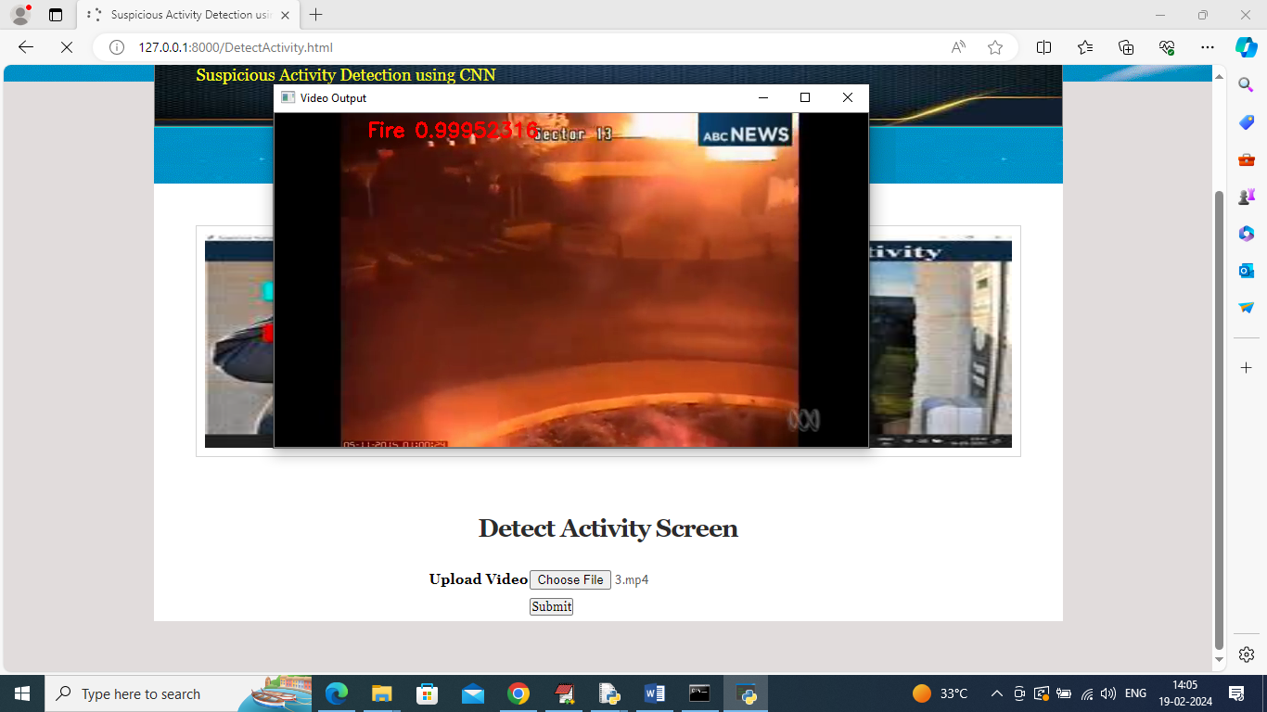

In above screen Fire detected

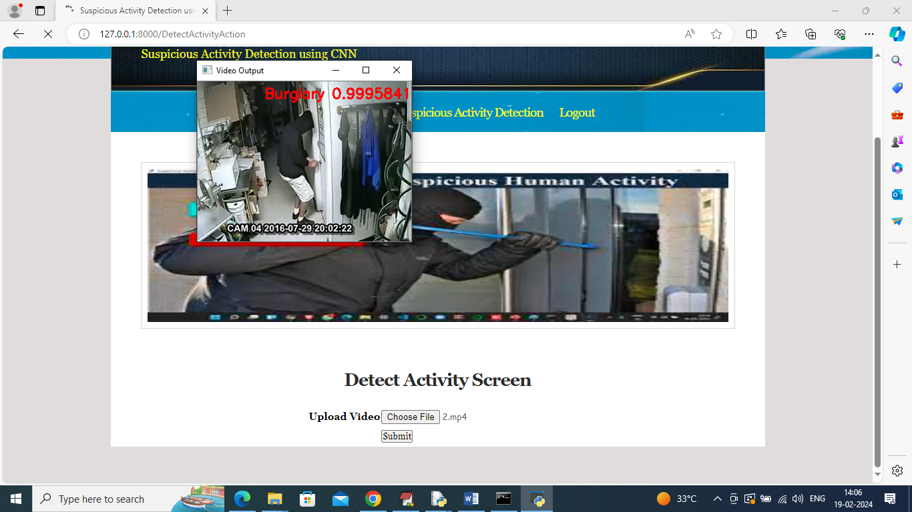

In above screen Burglary detected and similarly you can upload and test other videos and while video playing you can press ‘q’ to terminate playing and upload other videos.

Below testing video we have downloaded from net

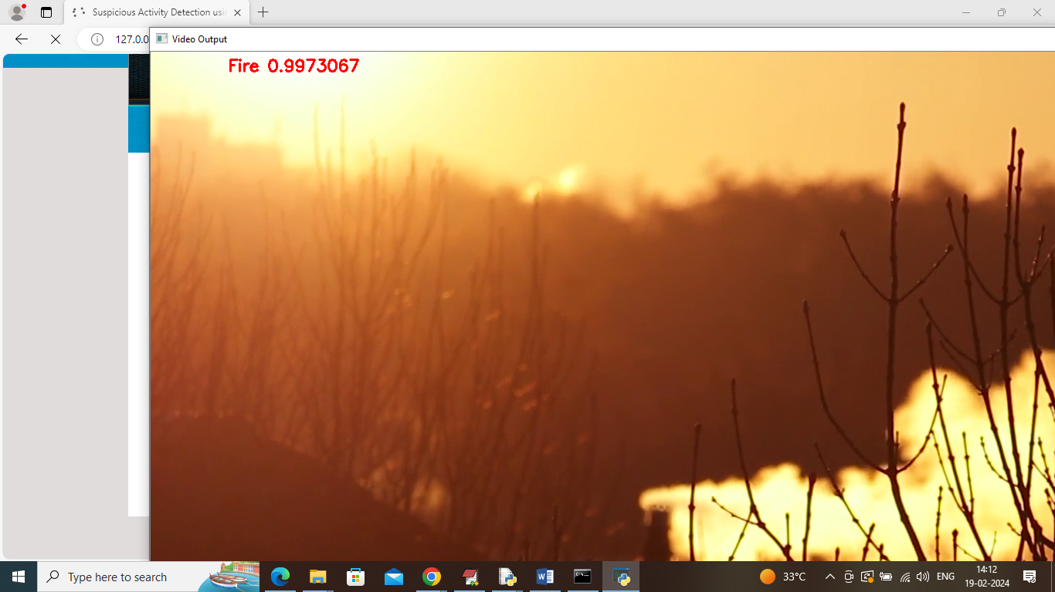

It was downloaded from below page



Fire video downloading and testing from above page and Shooting video downloading from below page



Above video detection output showing in below page

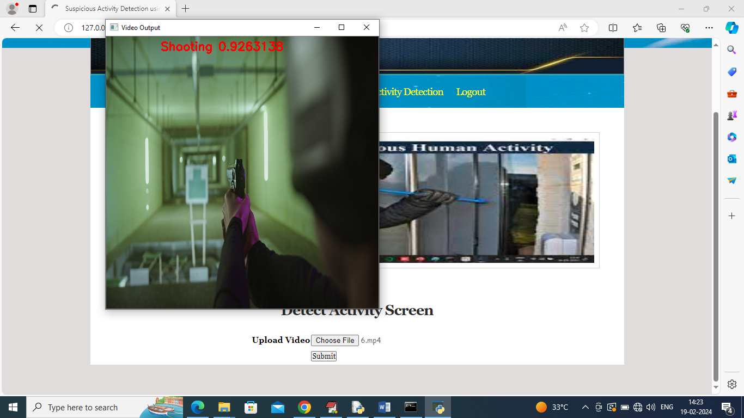

In above video shooting is detected